Equipment
All machinery is state-of-the-art and in top condition to meet your tightest tolerances in both inch and metric dimensioning.

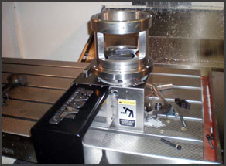
Vertical Machining Centers
- Fadal VMC 6030 VHT CNC Vertical Machining Center. Large 30"x62.5" table size 4000# work load capacity and table travel of 30"-Yx60"-X and vertical travel of 30" in Z-axis.
- Tree VMC 1260E CNC Vertical Machining Center. 50"-Y x 24"-X x 30"-Z axis travel maximum work capacity weight of 3,000#.
- Fadal VMC 6030 HT CNC Vertical Machining Center. Large 30" x 62.5" table size and table travel of 30"-Y x 60"-X and vertical travel of 30" in Z-axis.
- Fadal VMC 4020 CNC Vertical Machining Center. Large 20" x 47.94" table with axis travel of 20" x 40", spindle nose to table distance of 20" with table weight capacity of 4,000#.
- Hurco BMC-30 Vertical Machine Center. Large 16" x 40": with weight capacity of 2,400#.
- Hurco KM3P CNC Vertical Milling Machine. Large 14" x 49" table with axis travel of 14" x 24". Spindle nose to table distance of 17.25" with table weight capacity of 750#.

LATHES
-HAAS CNC Lathe. 25.5” x 44” max capacity, 34.5” swing
- Dianichi F30 CNC Universal Turning Machine. 21.6" swing x 50" turning length from 35-3500 RPM
- Dianichi F20 CNC Universal Turning Machine. 10" swing x 23" turning length from 45-4500 RPM
- Hitachi 4E CNC Lathe. 8" dia x 24" long, 35 - 4000 RPM
- Clausing Colchester 15" x 50" Lathe
- Summit Manual Lathe - 19" x 80"
- Clausing Metosa 14" x 40" Lathe
- South Bend Manual Lathe - 17" tool room lathe
- Lagun Deluxe Vertical Milling Machine - 54" x 11" table
- Bridgeport Mill 2J2 Head 9" x 48" table
- Bridgeport Mill 2J2 Head 9" x 42" table
- Bridgeport 2J Head 9" x 42" table
- Climax Portable Mill

GRINDING
- Chevalier model FSG-1224AD11 Automatic Hydraulic Surface Grinder with 12" x 24"
- Blanchard 36" Rotary Table #16
- Harig 612 Hand Surface Grinder
- Norton Tool Grinder

Q.C. Inspection
- Mititoyo BRT-M507 Bright coordinate measuring machine 20" x 28" x 15"
- Roughometer RMS Gauging System Autodrive SR-17 Surface tester

Engineering & Software Capabilities
-Auto Desk Inventor Pro 2016
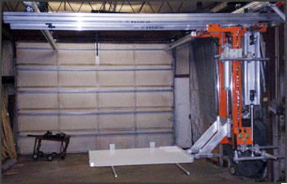
-Complete Auto-CAD 2016
-MasterCam – Solids, CAD/CAM
Rhino 5 – for 3D

Cutting
- Hyd-Mech 13" x 18" capacity Model S-20A automatic indexable
- Marvel 81-HC High Column Vertical Bandsaw 18" x 24" capacity.
- Marvel #8-HC High Column Vertical Bandsaw 18" x 24" capacity.

BENDING AND SHEARING
- HTC Hydraulic Shear ½" thick x 10' long
- Accupress 320 - 320 ton 14' Pressbrake
- Web 2A - Intial Pinch plate roll 1/4"

WELDING
- Miller Tig Dial Arc HF AC-DC High Frequency Heli-Arc Welder.
- Lincoln Mig Welder Ideal Arc SP-200
- Miller Matic 300 Amp Speed Gun
- 4 - Hobart 300 Amp Mig Machines with Feeders
- Hyper therm Max 100 Plasm Arc

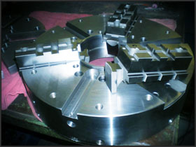
SUPPORT EQUIPMENT
- Hydraulic Test Stand for various hydraulic equipment and product testing with 5HP; 4.0 gpm; standard 1500 psi pressure with capabilities to 5000 psi as required.
- Geka 110 Iron Worker
- 12-ton x 42" wide 16 gauge Di-Acro hydraulic press brake.
- Di-Acro 16 gauge notcher.
- Various standard and miscellaneous sheet metal punches and tooling for multiple sheet metal operations
- 50 Ton Enerpac H-Frame Hydraulic Press
- Heat Treat Furnace Huppert 2,200 degree
- Tempering Furnace3 Huppert 600 degree
- Ridged 535 Pipe Threading Machine
- Ransburg Electrostatic Painting System.

